Time: 60 minutes
Directions: Each of the 30 multiple-choice questions is followed by five possible answer choices. Choices A through D will provide answers, while Choice E is for none of the above. Scoring will be as follows: 5 points for a correct answer, 0 for a wrong answer, and 1 for a blank answer (for a maximum possible score of 150). Figures are not necessarily drawn to scale. Do not choose incomplete answers: if a question has more than one solution, do not select a choice that only provides one of the solutions!
Calculators are not permitted.

- Solve for x: 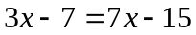
A) -2 B) -1 C) 1 D) 2 E) NOTA

- Evaluate 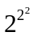.
A) 2 B) 4 C) 8 D) 16 E) NOTA

- Express 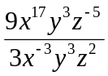 in simplest terms using no negative exponents.
A) 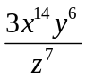 B)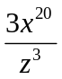 C)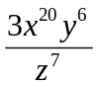 D) 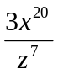 E) NOTA

- The two legs of a right triangle are 10 and 24. What is the length of the hypotenuse?
A) 26 B) 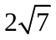 C) 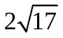 D) 676 E) NOTA

- What is the slope of a line that passes through the points (2, 54) and (-32 , 40)?
A) 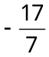 B) 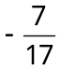 C) 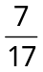 D)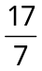 E) NOTA

- Simplify 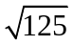.
A) 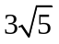 B) 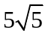 C) Can not be simplified
D) 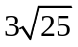 E) NOTA

- 25% of x is 50% of y. Find ?
A) ½ B) 2 C) y D) z E) NOTA

- Solve for all values of x, given the following 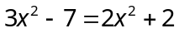
A) -3 B) 3 C) -3 and 3 D) -9 and 9 E) NOTA

- What is the units digit of the product (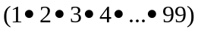?
A) 0 B) 1 C) 2 D) 3 E) NOTA

- 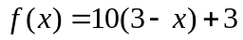 Find 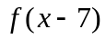.
A) 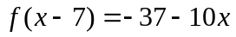 B) 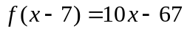 C)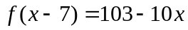
D) 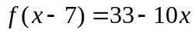 E) NOTA

- Solve 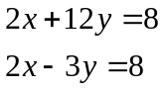
A) (0,0) B) (0,4) C) (4,2) D) (4,0) E)NOTA

- Choose which of the following are true:
- For any number 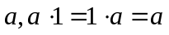is the definition of the Multiplicative Identity Property.
- For any number is the definition of the Multiplicative Property of a.
- For any number 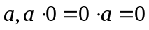is the definition of the Multiplicative Property of 0.
- For any number is the definition of the Multiplicative Property of a.
A) I, IV only B) II, III only C) I, III only D) II, IV only E) NOTA

- 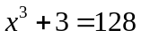 Solve for .
A) 5 B) -5 C)-5, 5 D)-25, 25 E) NOTA

- Roland has 10 bunnies. Two bunnies are eaten by rabid wolves. What was the percent change in the number of bunnies Roland had?
A) 12% B) 20% C) 80% D) 100% E) NOTA

- A train is traveling along the train track on line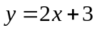. The Green Goblin is at point (-4, 2) and wants to intercept the track at a 90 degree angle so he will land perfectly on top of the train for an epic fight scene. What line will the green goblin have to travel along to accomplish this landing?
A) 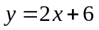 B) 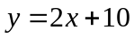 C)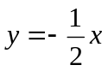 D) 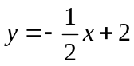 E) NOTA

- Spiderman swings from building to building on a parabolic path. The equation of one particular swing like this is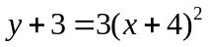. What are the x-intercept(s) of this swing?
A) 3, 5 B) -3, -5 C) -5 D) -4 E) NOTA

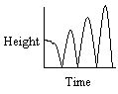
- Spiderman scales the roofs of New York in his spare time. One day he decides to watch a super bouncy ball as he throws it off a very high building. Which of these graphs most closely represents the path of the bouncy ball if the ball bounces back to half of its previous height with each successive bounce?
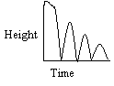
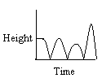
A) B) C)

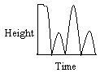
D) E) NOTA

- If he throws the ball from a 200 ft building and after each bounce it only reaches 75% of its previous height, how far will the ball travel vertically between the first and second bounces (from the first time the ball hits the ground until the second time the ball hits the ground)?
A) 150 ft B) 200 ft C) 300 ft D) 400 ft E) NOTA

- If Spiderman is at point (4, 3), and Mary Jane is at point (1, -1), what is the midpoint between the two?
A) (4,-1) B) (1,3) C) (2.5,1) D) (2.5,-1) E) NOTA

- Spiderman is at (5, 3). Mary Jane is at another point, (0, 3). Spiderman also needs to defeat the Joker (since Batman is sick) at (0, -9) If it takes Spiderman 1.5 minutes to travel one unit, what is the minimum travel time necessary for Spiderman to see Mary Jane and beat up the Joker? Remember that he can do either in any order.
A) 20.0 minutes B) 23.5 minutes C) 25.0 minutes
D) 28.5 minutes E) NOTA

- Solve for x over real numbers. 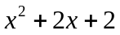=0
A) -1, 1 B) 1 C) -1 D) No solution E) NOTA

- It takes Spiderman 5 minutes to beat an average bad guy. If Superman takes about 10 minutes (he likes the long drawn out talks), how many bad guys can both of them, working together, beat up in 1 hour?
A) 5 B) 10 C)15 D) 18 E) NOTA

- Simplify 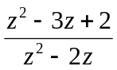.
A) 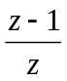 B) 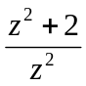 C) 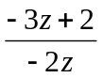 D) Cannot be simplified E) NOTA

- Express 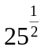 without exponents.
A) 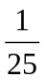 B) 5 C) 5.2243 D) 12.5 E) NOTA

- Simplify 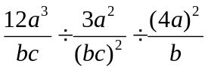.
A) 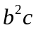 B) 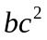 C) 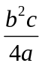 D) 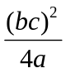 E) NOTA

- Peter Parker delivers pizzas for Joe’s Pizza. Joe’s Pizza has been in business for 12 years. Three years ago, Fred’s Pizza was twice as old as Joe’s Pizza. How old is Fred’s Pizza now?
A) 12 B) 18 C) 20 D)21 E) NOTA

- Evaluate 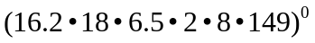.
A) 16.2 B) 0 C) 16 D) -16.2 E) NOTA
- Write the following equation in slope-intercept form. 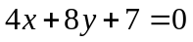
A) 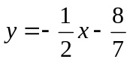 B) 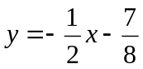 C) 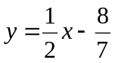 D)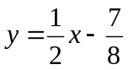
E) NOTA

- 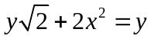. Solve for.
A) 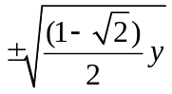 B) 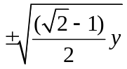 C) 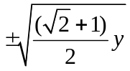 D) 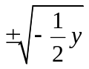
E) NOTA

- The Green Goblin hurls a bomb along the line 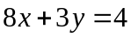. Spiderman intercepts it with web by shooting along the line 6x + 3y = -4 at the same rate of speed. At what point does Spiderman’s web intercept Green Goblin’s Bomb?
A) (4, 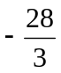) B) (4, -1) C) (, 4)
D) (-1, 4) E)NOTA

CHILES MINI MU COMPETITION
ALGEBRA I – SPIDERMAN VS. THE EQUATION HATER
ANSWERS

- D
- D
- D
- A
- C
- B
- A
- C
- A
- C
- D
- C
- A
- B
- C

- B
- A
- C
- C
- E
- D
- D
- A
- B
- C
- D
- E
- B
- A
- A

SOLUTIONS

- D. 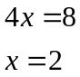
- D. =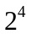=16
- D. 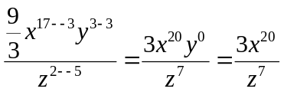
- A. Divide all sides by 2, and you have a special 5, 12, 13 right triangle.
- C. 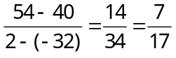
- B. =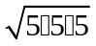=
- A. 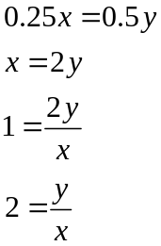
- C. 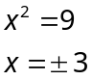
- A. Between 1 – 99, there are multiple numbers that end in zero ( 10, 20, 30, etc.) causing the units digits of the final number to be zero.
- C f(x-7) = 10(3-(x-7))+3=10(3-x+7)+3=10(10-x)+3=100-10x+3=103-10x
- D. 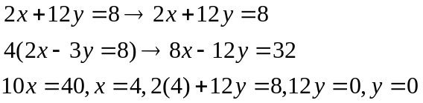
- C. By definition in Algebra 1 textbook.
- A. 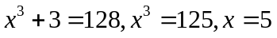
- B. 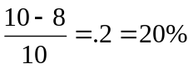
- C. Because the line is perpendicular, the slope must be the opposite reciprocal of the slope of , so it is 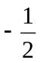. You then plug this in with slope intercept form. Solve this to get .
- B. Plug in 0 for y and solve, to get -3, -5.
- A. The ball will bounce lower and lower on each consecutive bounce. The only chart which shows this is the first.
- C. 200(.75) (going up) + 200(.75) (going down) = 300
- C. 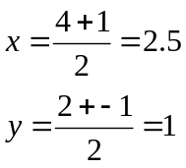
- E. Because these points form a 5, 12, 13 triangle, Spiderman should first travel along the 5, then the 12 side to make the shortest route possible. 5+12=17, and multiply that by 1.5 and that equals 25.5 minutes, which gives the answer E, none of the above.
- D. x=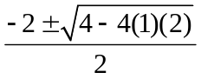, and that leaves a negative number under the radical, so there is no solution.
- D. Spiderman can beat 12 bad guys in an hour, and Superman can beat 6, so together they can beat 18 bad guys in one hour.
- A. 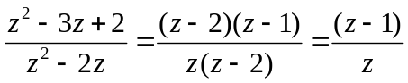
- B. =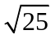=5.
- C. 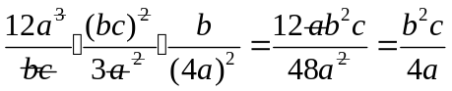
- D. 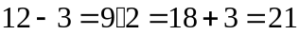years
- E. Any non-zero number to the zero is one.
- B. 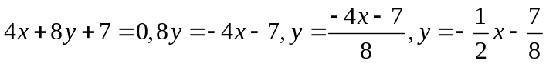
- A. 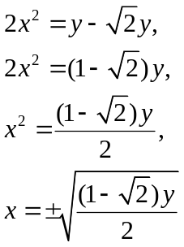
- A. 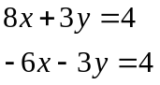;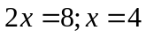;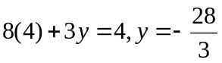, so the point of intersection is (4, )

